BA Capstone Project: Checkpoint 1

Data Fundamentals & SQL Querying
Group Name: Group 1 – The Data Bookworms
Course & Section: BED 106 - Business AnalyticsDate: August 24, 2026
Team Members & Roles:

- Peter Paul Polestico — Project Lead / Analyst
— BI Developer / Visualizer
- Ken T. Lubrico — Data Engineer
- Johnro Balingit — Statistician / Modeler

Task 1.1 — Business Problem Statement

Business Domain & Problem Investigation
Business Domain: Education Analytics — Academic Digital Library Services.
Business Problem: The academic library currently has no data-driven way of understanding how different patron types (undergraduates, postgraduates, faculty, and research scholars) actually borrow and engage with the collection, which book categories and formats drive real engagement, and whether the library's recommendation/discovery experience serves new (“cold-start”) patrons as well as it serves established ones. This project investigates borrowing and reading-interaction behavior across the library's patron base — with a primary focus on students (undergraduate and postgraduate), its largest combined user group — using a library book-recommendation interaction dataset.

Business Impact & Significance
Understanding these interaction patterns matters because a library's acquisition budget and recommendation/discovery features only pay off if they match how patrons actually behave. In this dataset, 18.5% of all recorded events come from cold-start (new/low-history) patrons, and while they search and read for essentially the same amount of time as established patrons, their average recommendation score is about 17% lower (0.478 vs 0.574) — concrete evidence that new patrons are not yet being served as well by the current recommendation experience. Roughly 1 in 6 events (15.8%-17.1%, varying by department) is flagged as irregular borrowing behavior. By identifying which patron types, departments, and categories drive engagement, low satisfaction, or irregular behavior, the library can prioritize onboarding improvements, targeted outreach, and collection decisions where they will have the most impact.

Key Business Questions
List the specific questions you aim to answer through your data analysis:
1. Which patron types and departments show the highest rate of irregular borrowing behavior, and could benefit from targeted outreach?
2. Which book categories and formats generate the most real engagement (borrows, views, reservations), and does that engagement pattern differ by patron type?
3. Are cold-start (new) patrons underserved by the recommendation experience compared to established patrons, despite putting in similar effort (search activity, reading time)?

Data Source Overview
Data type: Structured interaction data covering individual patron-book events at an academic digital library — who interacted (patron type, department), what was interacted with (book category, format), how (borrow / view / search / reserve / renew), and a set of engagement and recommendation-quality metrics for that event. Source: Academic Digital Library Book Recommendation Dataset, downloaded from Kaggle. This is a synthetic/simulated dataset built to model library recommendation-system behavior rather than a scrape of a real institution's circulation logs (see the Preliminary Data Quality Assessment below for how this was determined); it is used here, consistent with Section 1.6 of the project guide, as an instructor-style realistic sample dataset. 12,000 patron-book interaction events were downloaded directly from Kaggle, comfortably exceeding the minimum-200-row requirement in Section 1.6.

Task 1.2 — Dataset Documentation

Data Source Report
Attribute | Details
Dataset Name | Academic Digital Library Book Recommendation Dataset
Source URL/File | https://www.kaggle.com/datasets/colabsss/academic-library-book-recommendation-data
Date Accessed | August 25, 2026
License Type | [Confirm the exact license shown on the Kaggle dataset page and enter it here] — NOTE: this dataset is synthetic/simulated, not scraped circulation records (see Preliminary Data Quality Assessment below)

Data Dictionary
Column Name | Data Type | Description
user_id | VARCHAR(15) (PK) | Unique identifier for each library patron (e.g., USR_10001)
user_type | VARCHAR(20) | Patron type: Undergraduate, Postgraduate, Faculty, or Research_Scholar
department | VARCHAR(30) | Academic department the patron belongs to
book_id | VARCHAR(15) (PK) | Unique identifier for each book/catalog item (e.g., BK_50001)
book_category | VARCHAR(30) | Subject category of the book (e.g., Data_Science, Literature, Law)
book_format | VARCHAR(20) | Format of the item: Printed_Book, E_Book, Reference_Book, or Journal
event_id | INT (PK, auto-generated) | Surrogate key identifying each interaction event; not present in the raw source file, generated during database loading
interaction_type | VARCHAR(20) | Type of interaction: Borrowed, Viewed, Reviewed, Reserved, or Renewed
access_mode | VARCHAR(20) | Channel used for the interaction: Web_Portal, Digital_Kiosk, Mobile_App, or Library_System
semester_period | VARCHAR(20) | Academic period of the event: Odd_Semester, Even_Semester, or Vacation_Period
borrowing_frequency | INT | How often this patron borrows overall (1-45 scale)
reading_duration_minutes | DECIMAL(6,2) | Minutes spent reading/engaging with the item in this event
books_borrowed_last_6_months | INT | Count of books this patron borrowed in the last 6 months
books_returned_on_time | INT | Count of this patron's books returned on time
search_count | INT | Number of catalog searches performed by this patron
book_view_count | INT | Number of times this patron viewed the book's record
reservation_count | INT | Number of times this patron reserved items
renewal_count | INT | Number of times this patron renewed a loan
user_rating | DECIMAL(3,2) | Patron's rating of the book (1-5 scale)
book_popularity_score | DECIMAL(4,3) | Normalized popularity score for the book (0-1 scale)
metadata_match_score | DECIMAL(4,3) | How well the book's metadata matched the patron's search/profile (0-1 scale)
reading_interest_score | DECIMAL(4,3) | Modeled interest score for this patron-book pair (0-1 scale)
user_book_similarity_score | DECIMAL(4,3) | Similarity between the patron's profile and the book (0-1 scale)
feedback_score | DECIMAL(4,3) | Numeric feedback score for the event (0-1 scale)
feedback_level | VARCHAR(10) | Categorical feedback: Low, Medium, or High
cold_start_user | TINYINT(1) | 1 = new/low-history patron, 0 = established patron
irregular_borrowing_flag | TINYINT(1) | 1 = irregular borrowing pattern flagged, 0 = normal
recommendation_score | DECIMAL(5,3) | Output score from the recommendation model (0-1 scale)
recommendation_level | VARCHAR(25) | Categorical recommendation strength: Low_Recommendation, Medium_Recommendation, or High_Recommendation

Preliminary Data Quality Assessment
- Missing Values: The raw Kaggle export (academic_digital_library_book_recommendation_dataset.csv) contains no missing or blank values across all 12,000 rows and 28 columns — every event has a complete set of patron, book, interaction, and score fields.
- Duplicates: No exact duplicate rows were found. However, every User_ID and every Book_ID also appears exactly once across the 12,000 events — the file represents 12,000 distinct patron-book pairs, each interacting exactly once — and both ID series increment in perfect lockstep with row order (USR_10001...USR_22000, BK_50001...BK_62000). Combined with near-perfectly balanced category distributions (e.g., every patron type sits within about 2 percentage points of the others) and cases where Books_Returned_On_Time exceeds Books_Borrowed_Last_6_Months for the same row — which is not possible in a genuine circulation log — the team concluded this dataset is synthetically generated to model recommendation-system behavior rather than a scrape of real circulation logs. This is disclosed here rather than presented as authentic institutional data, and it is also why Books_Borrowed_Last_6_Months and Books_Returned_On_Time are treated as independent descriptive counts rather than combined into a return-rate ratio anywhere in this report.
- Inconsistencies: Cold_Start_User and Irregular_Borrowing_Flag are stored as text ('Yes'/'No') in the raw CSV rather than as proper boolean/numeric types. All categorical fields (User_Type, Department, Book_Category, Book_Format, Interaction_Type, Access_Mode, Semester_Period, Feedback_Level, Recommendation_Level) use a small, consistent, cleanly-spelled set of values with no stray casing or whitespace issues.
- Cleaning Steps Applied: (1) Cast Cold_Start_User and Irregular_Borrowing_Flag ('Yes'/'No') to TINYINT(1) columns; (2) generated a surrogate event_id (AUTO_INCREMENT) since the raw file has no native event key; (3) split the single flat export into three normalized tables (users, books, borrowing_events) with primary/foreign keys before loading into MySQL; (4) verified referential integrity — every User_ID and Book_ID referenced in the interaction data exists in its corresponding dimension table.

Raw Dataset Preview

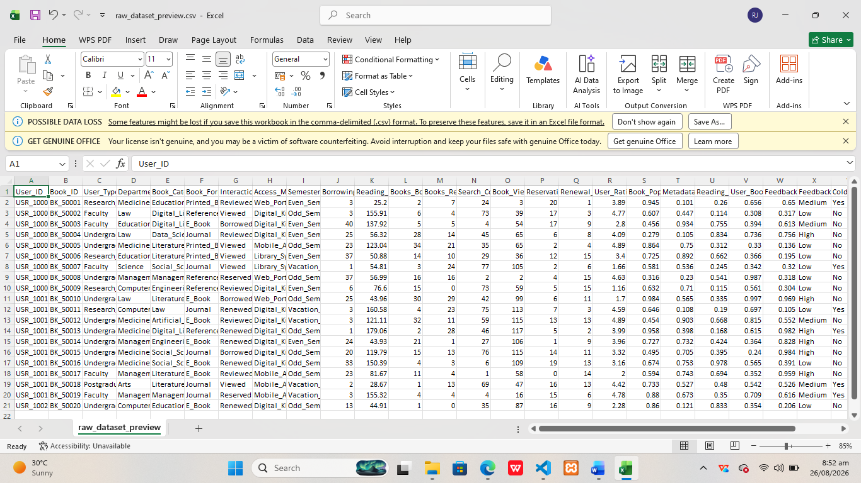

Task 1.3 — Relational Database Design

Entity-Relationship Diagram (ERD)

The ERD below shows three related tables: users and books are dimension tables, and borrowing_events is the fact table connecting them. A user can generate many borrowing/interaction events (1-to-many), and a book can appear in many events (1-to-many). See erd_diagram.png (inserted below) for the full diagram with primary keys (PK) and foreign keys (FK) labeled.

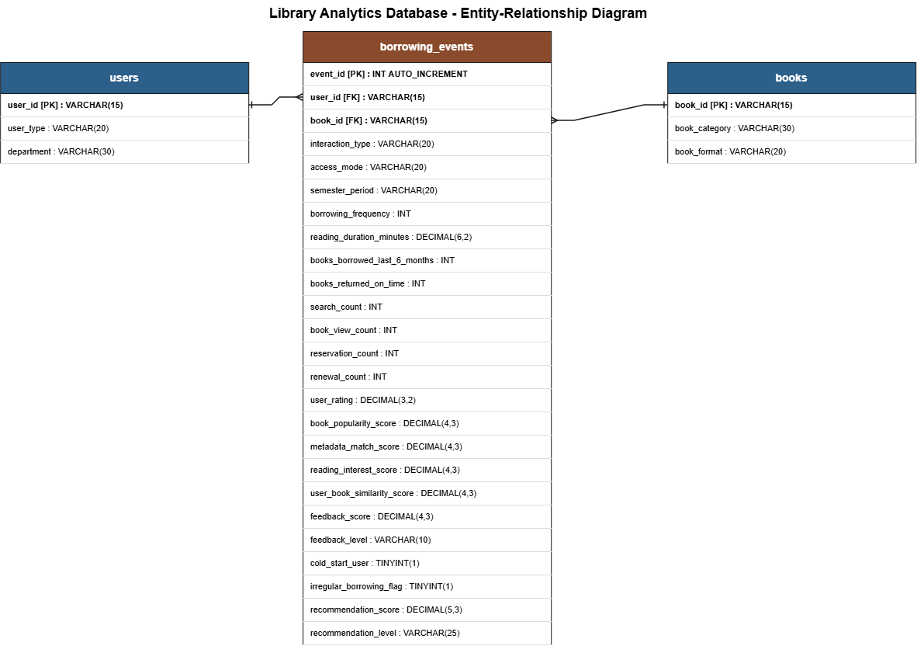

Database Schema & Population

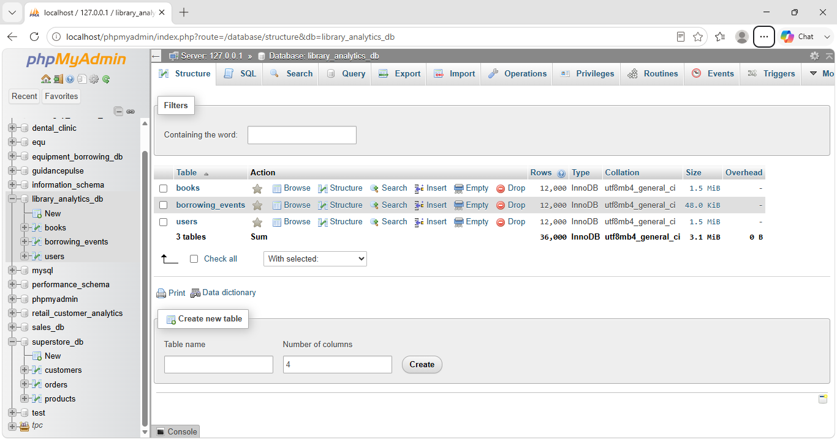

Task 1.4 — SQL Query Report

1. Basic Data Retrieval (2 Queries)
Must include SELECT, WHERE, and ORDER BY clauses.

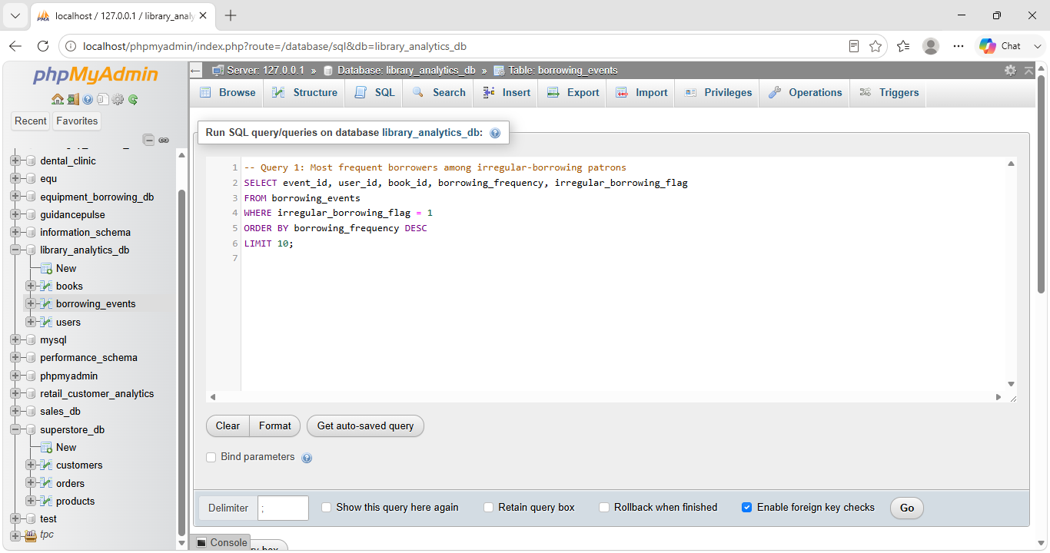

Query 1: Most frequent borrowers among irregular-borrowing patrons
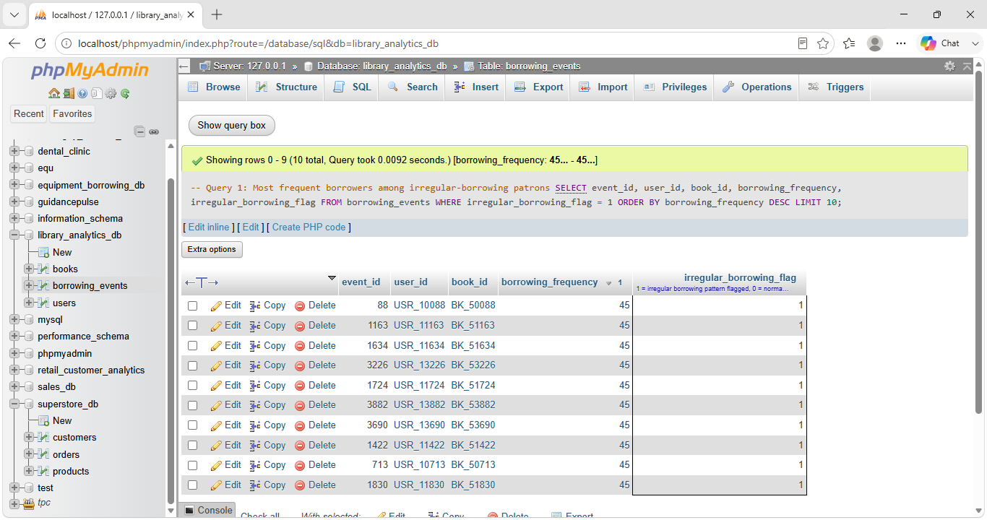

Result
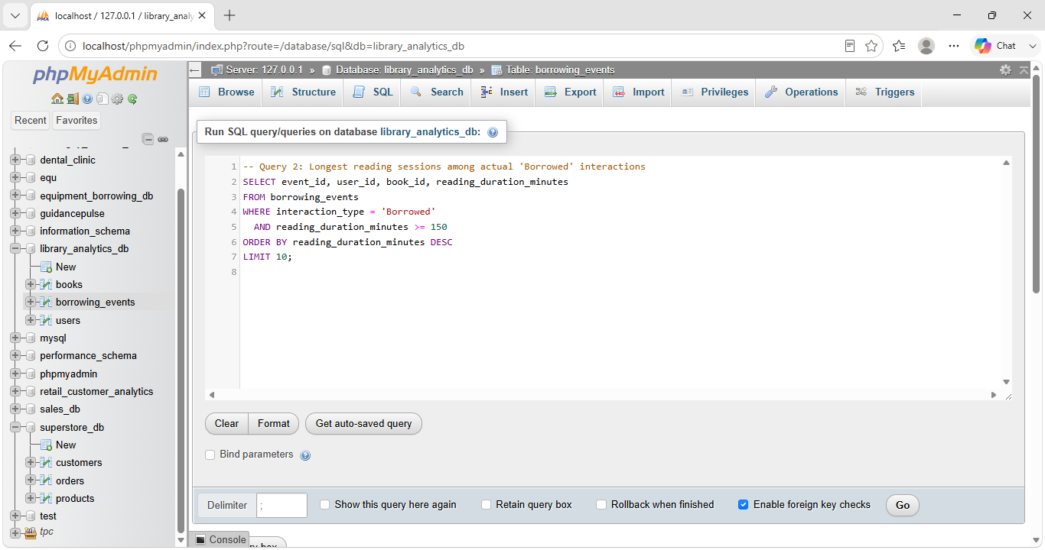

Query 2: Longest reading sessions among actual 'Borrowed' interactions

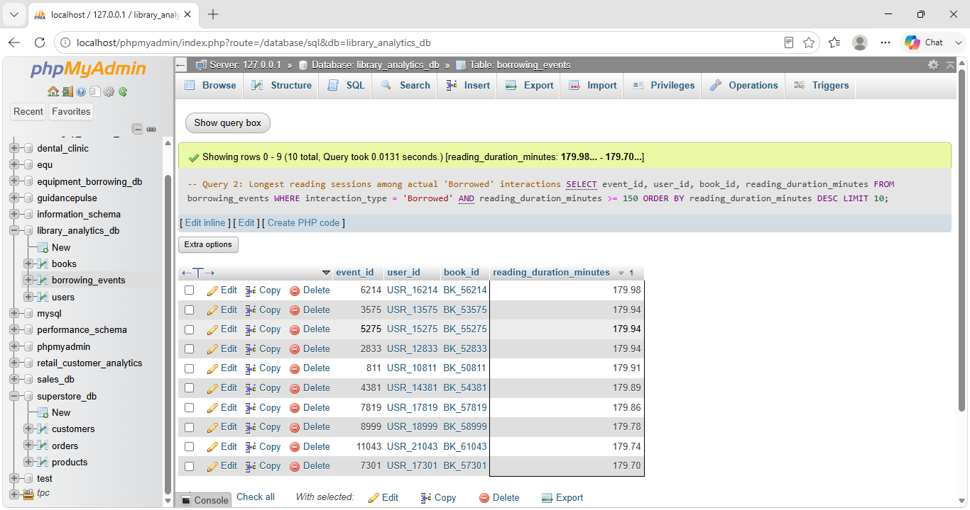

Result

Business Interpretation:
Query 1 surfaces patrons who borrow very often yet are still flagged as irregular — an edge case worth a manual review, since high frequency alone does not guarantee predictable borrowing behavior.
Query 2 identifies the most deeply engaged actual borrowing sessions, useful for spotting which loans represent the library's most invested readers rather than quick browsers.

2. Aggregate Analysis (2 Queries)
Must include GROUP BY and Aggregate Functions (COUNT, SUM, AVG, etc.).

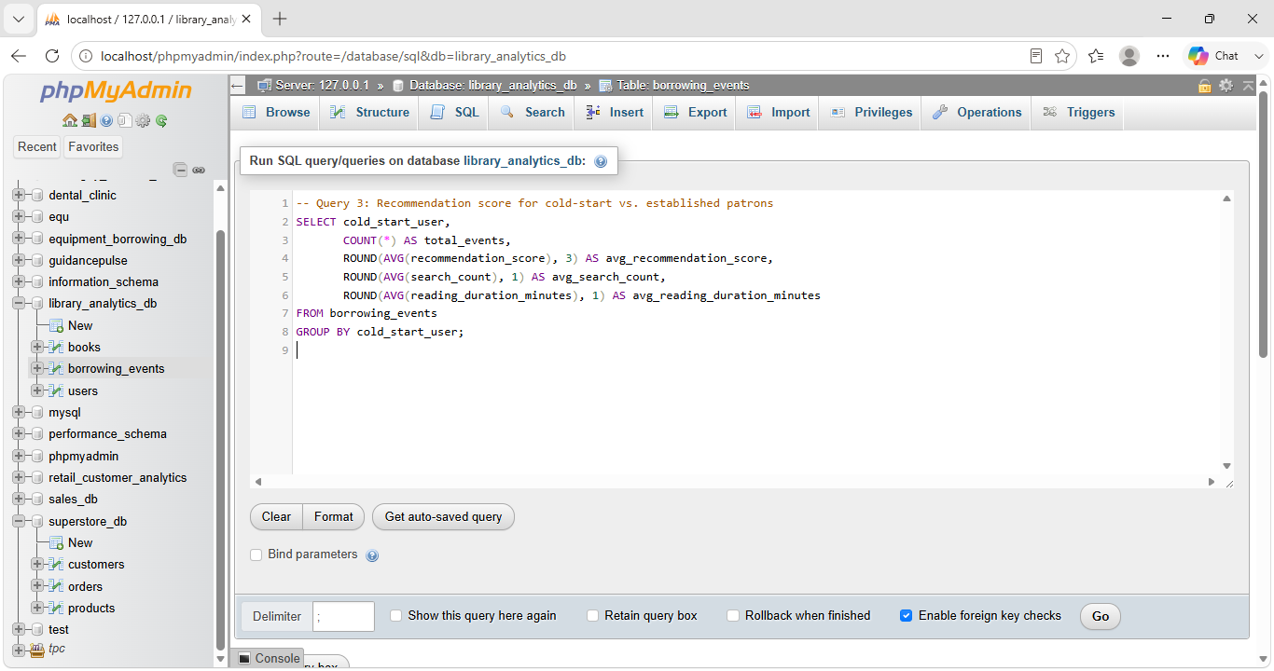

Query 3: Recommendation score for cold-start vs. established patrons

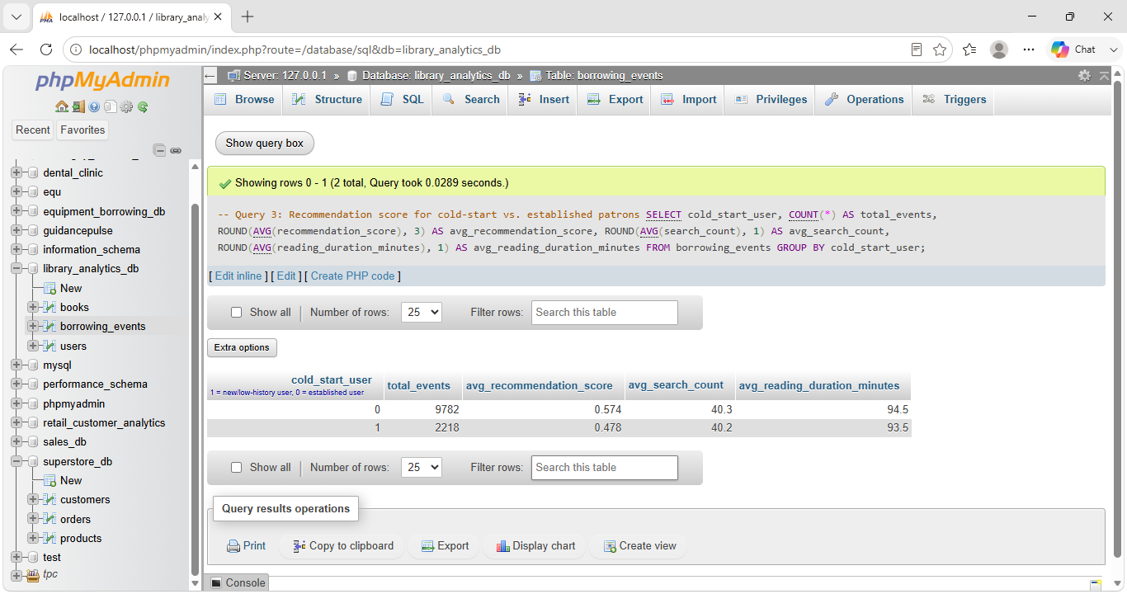

Result

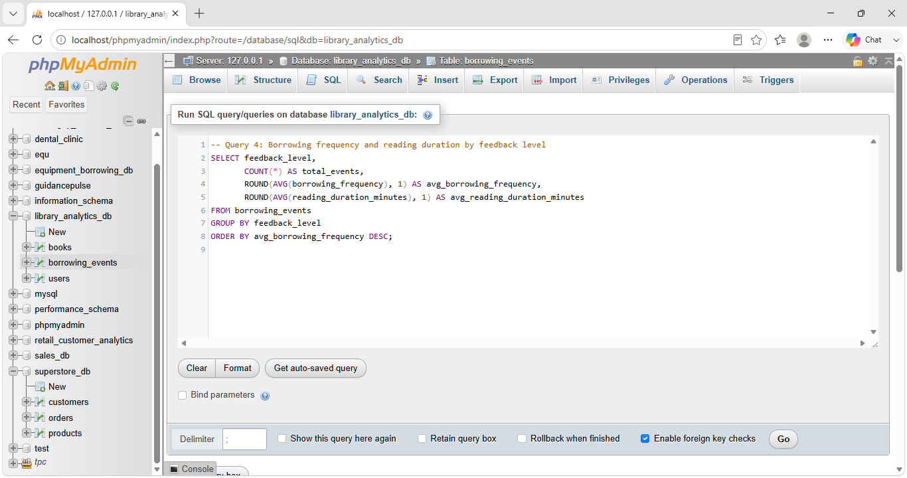

Query 4: Borrowing frequency and reading duration by feedback level
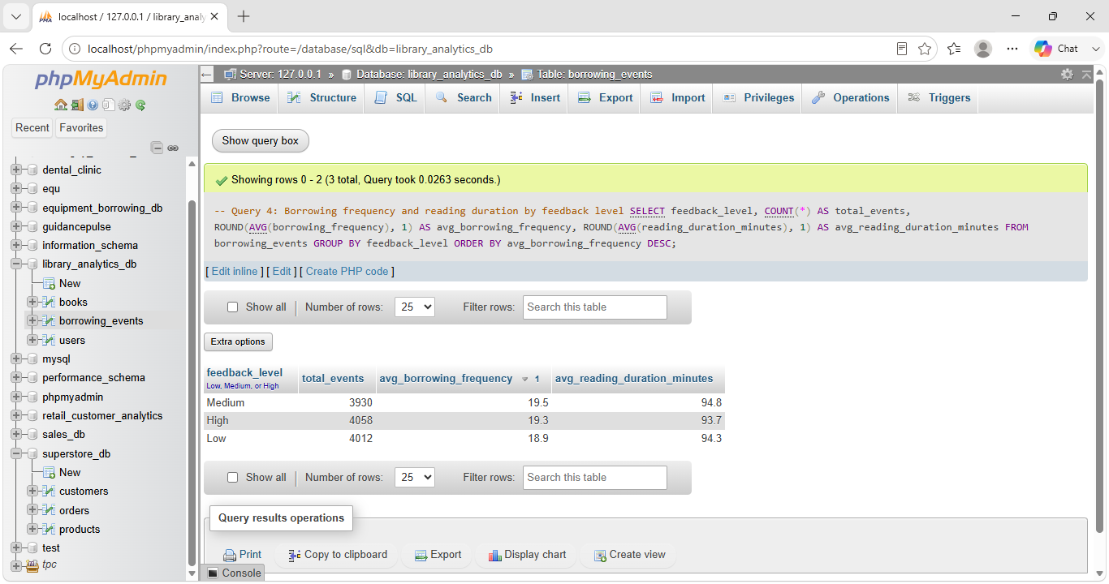

Result

Business Interpretation:
Query 3 shows cold-start patrons search and read for about the same amount of time as established patrons, but receive a noticeably lower average recommendation score (0.478 vs 0.574) — a real gap in how well the system currently serves new patrons.
Query 4 compares borrowing intensity across feedback levels, showing borrowing activity stays fairly similar (19.3-19.5 average frequency) regardless of how satisfied a patron says they are.

3. Multi-Table Joins (2 Queries)
Must connect two or more tables.

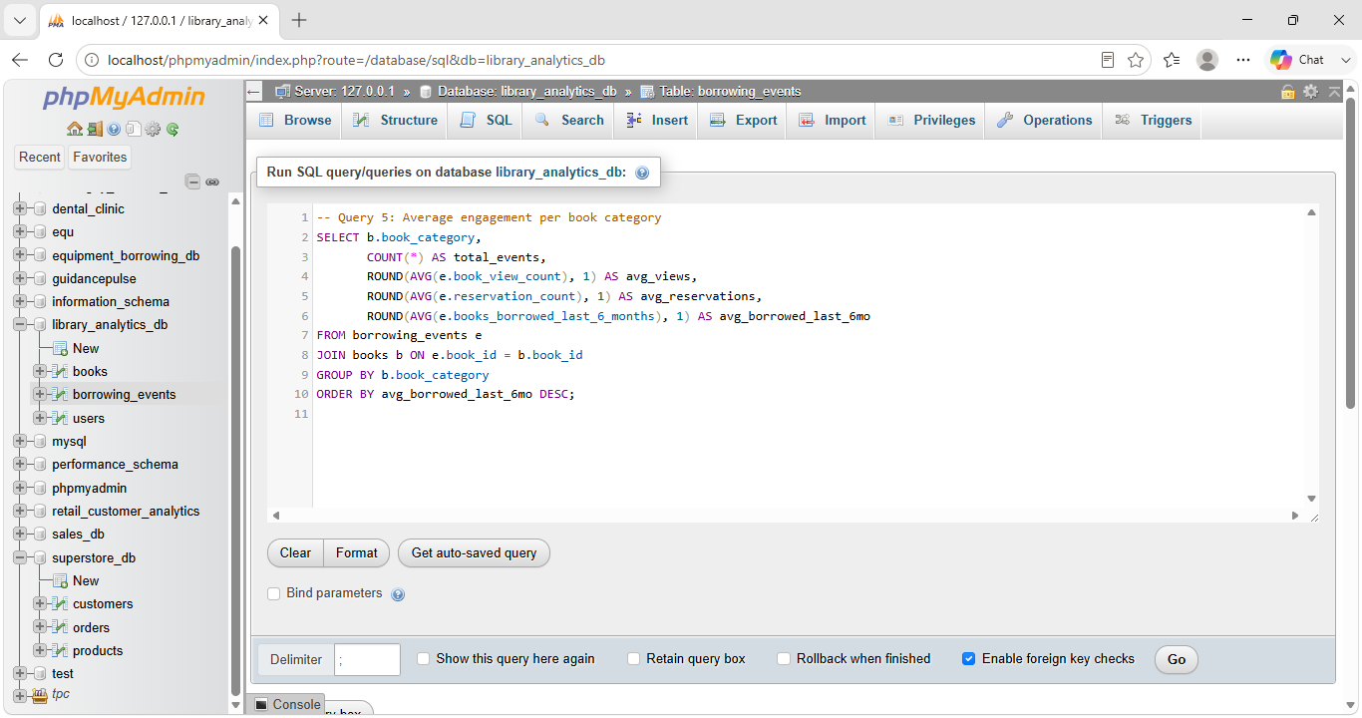

Query 5: Average engagement per book category

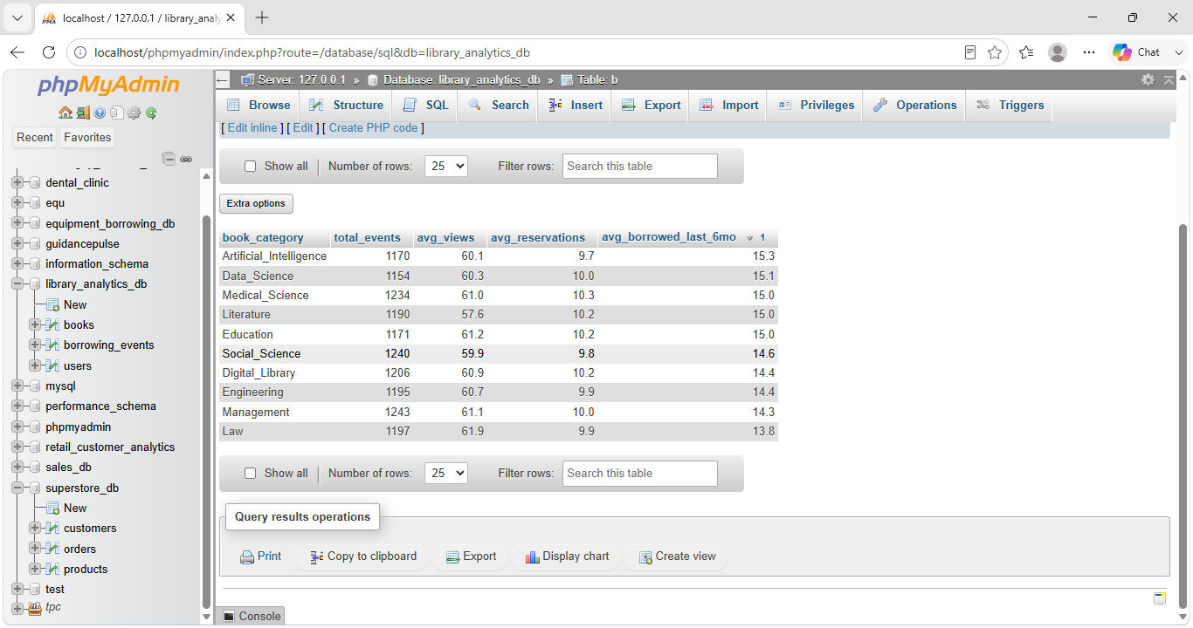

Result
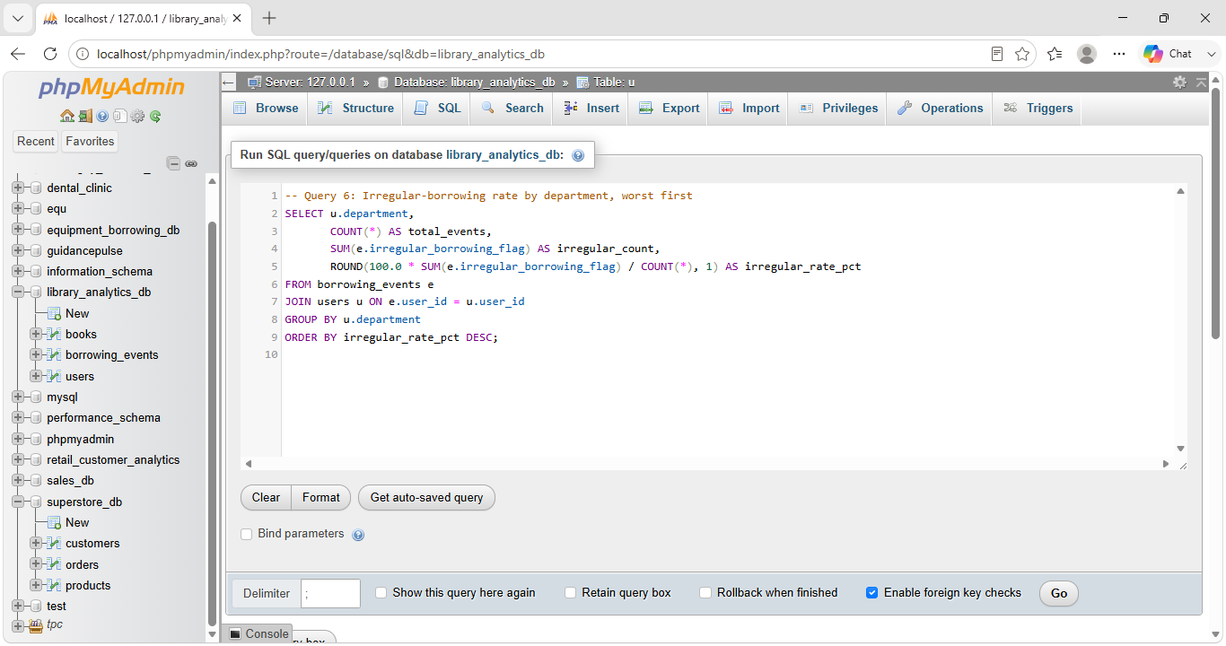

Query 6: Irregular-borrowing rate by department, worst first

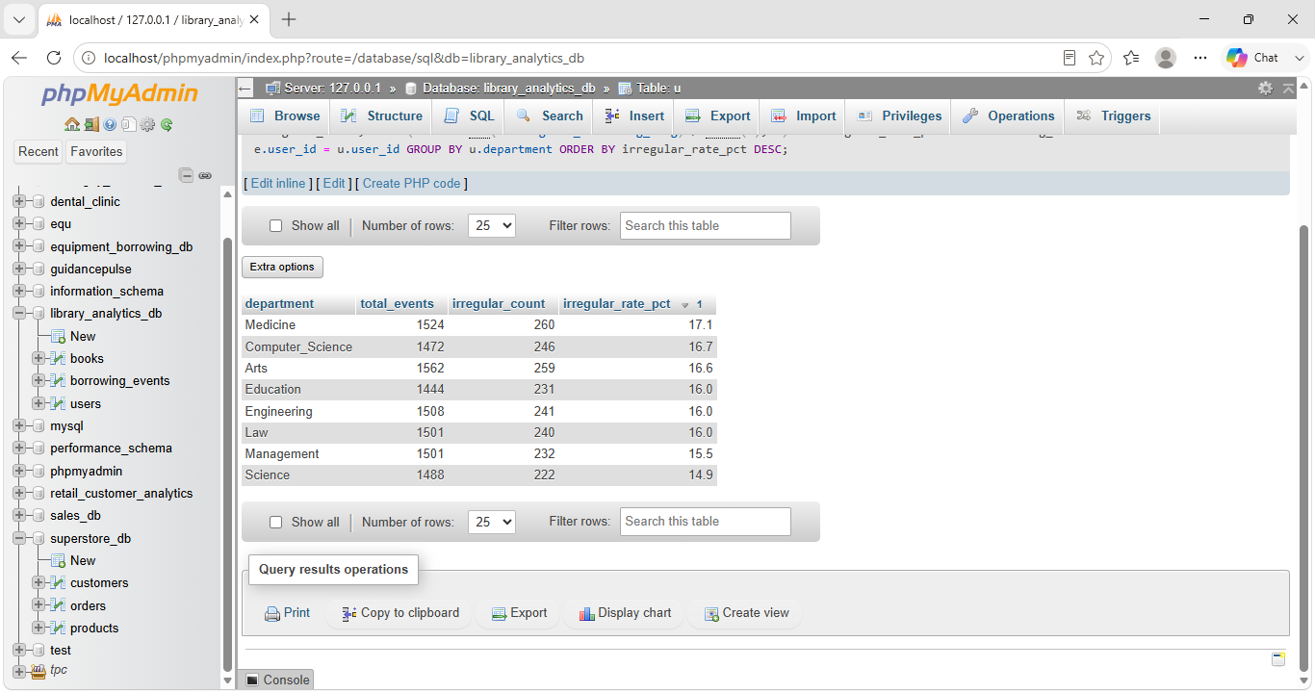

Result

Business Interpretation:
Query 5 ranks book categories by real engagement rather than raw title count, showing Artificial_Intelligence and Data_Science lead in average 6-month borrowing activity — useful signal for acquisition planning.
Query 6 shows Medicine (17.1%) and Computer_Science (16.7%) have the highest irregular-borrowing rates, pinpointing which departments would benefit most from a targeted borrowing-behavior outreach program.

4. Business-Relevant Insights (2 Queries)
Queries specifically designed to answer your key business questions listed in Task 1.1.

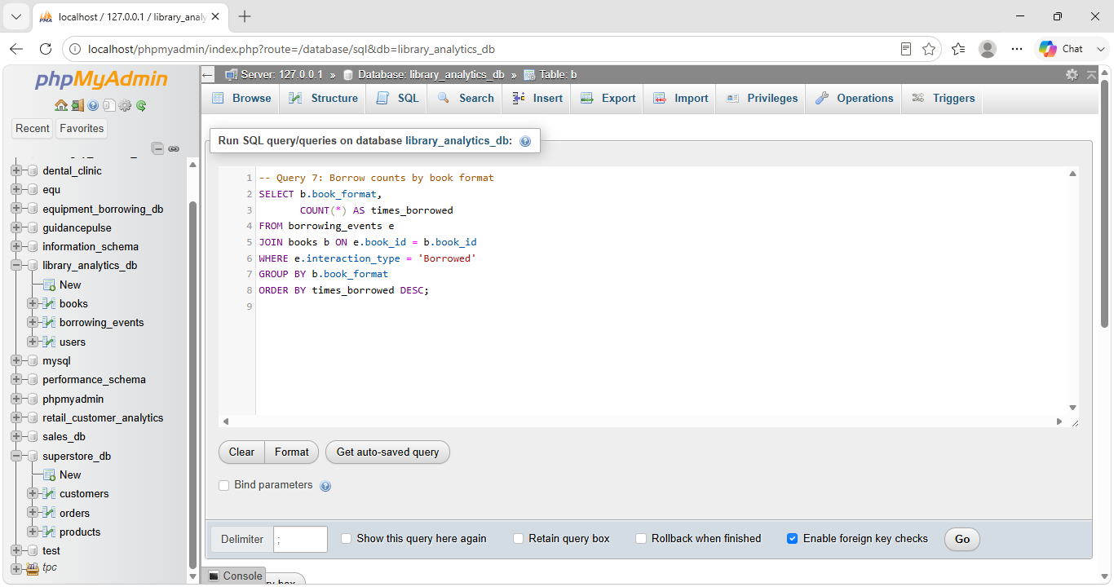

Query 7: Borrow counts by book format

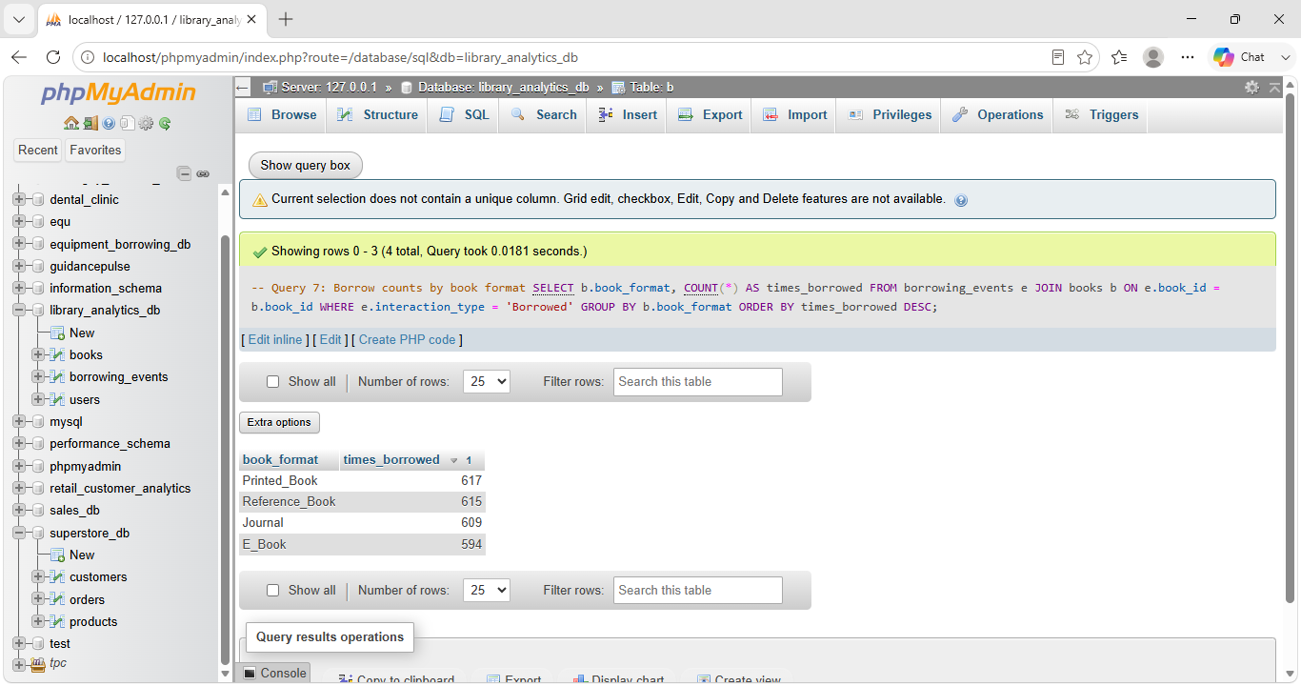

Result
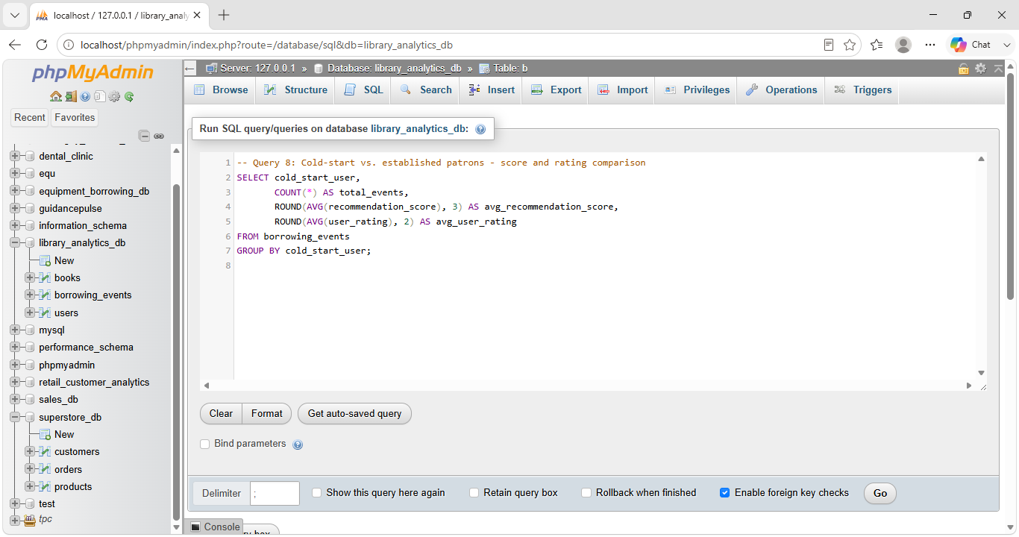

Query 8: Cold-start vs. established patrons - score and rating comparison

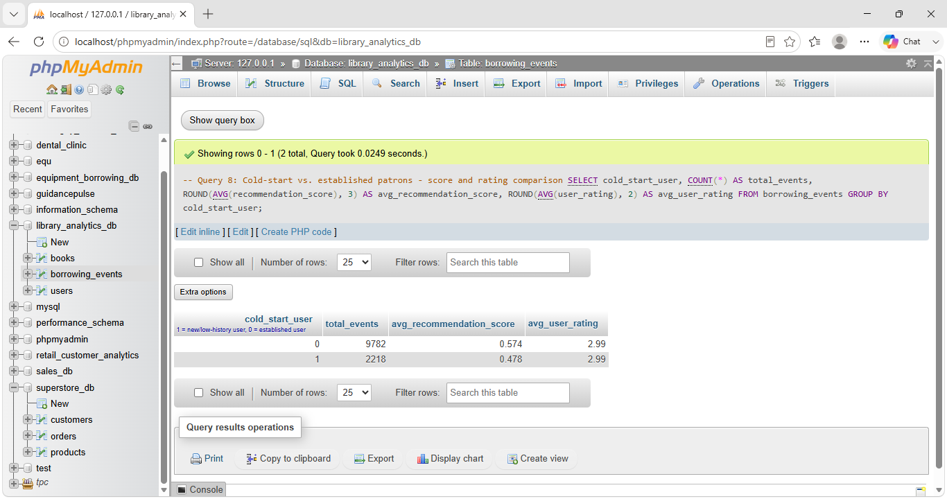

Result

Business Interpretation:
Query 7 shows Printed_Book, Reference_Book, Journal, and E_Book are borrowed at nearly identical rates (594-617 events each), so format is not a meaningful differentiator of demand in this dataset.
Query 8 shows the 18.5% of events from cold-start patrons give essentially the same average rating as established patrons (2.99 vs 2.99), yet receive an average recommendation score about 17% lower (0.478 vs 0.574) — concrete evidence the library's recommendation/discovery experience needs a better onboarding path for new patrons, a thread the team will extend into the Checkpoint 4 predictive model.

